Reviews, Awards & Lists

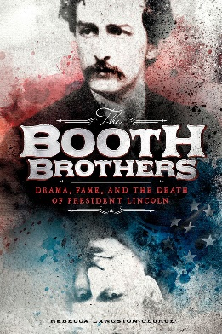 | School Library Journal, "Looking at U.S. History Through a Different Lens " - Jennifer Wharton  "This goes beyond the usual exciting and tragic story of Lincoln’s assassination to explain how two brothers, both well-known actors, could diverge so radically, one being a close friend of abolitionists and supporter of the Northern cause and the other to plot numerous dramatic attempts on Lincoln’s life and finally commit the crime for which the Booth name became known. The moment-by-moment account of the assassination plan is broken up by chapters explaining the larger context of the war and considering various perspectives of John Wilkes Booth’s actions. This is a good starting point for students to consider how their own family is affected by political disagreements and how they would face making difficult choices." - School Library Journal, "Looking at U.S. History Through a Different Lens " December 20, 2017
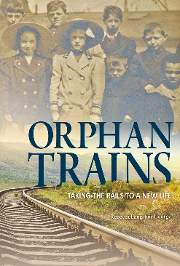 | VOYA - Lisa A. Hazlett  "Although many orphan train titles are available, this is particularly balanced by honestly portraying and discussing the system, children, recipients, and outcomes in context. Chapters alternate between relaying the stories of children placed with Western families and information regarding the orphan train system. . . .Although meant for middle level readers, this novel’s content will interest all ages." – VOYA December 1, 2016  2017 NCSS-CBS Notable Social Studies Trade Books for Young People  2017 VOYA Nonfiction Honor List
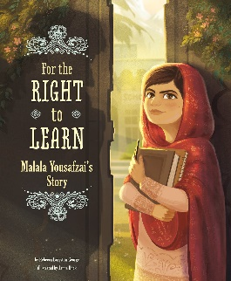 | A Mighty Girl, "Telling Her Story: 40 New Books for Women’s History Month" - Katherine  "This powerful version of Malala's story for younger readers proves that one person really can change the world." - A Mighty Girl, "Telling Her Story: 40 New Books for Women’s History Month" March 8, 2016  Book Dragon, Smithsonian Asian Pacific American Center - Terry Hong  "...a timely introduction to the life of an international hero who is not much older than the book’s intended audience. . . .Author Rebecca Langston-George carefully highlights the many accomplishments, recognition, awards, and fame that nearly cost Malala her life. Artist Janna Bock is especially adept at capturing Malala’s expressions – just take a look at that hopeful determination on the cover image. . . .Not yet even out of her teens, Malala’s story has really just begun. Her determination to learn – and keep learning at any cost – is inspiration, at any age, for us all." - Book Dragon, Smithsonian Asian Pacific American Center October 12, 2015  2016 Ultimate Mighty Girl Book Gift Guide  2016 Skipping Stones Multicultural Award  2017 Teachers’ Choice Awards, Learning Magazine
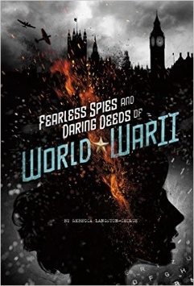 | YALSA, The Hub - Lisa Krok  "This inspiring nonfiction pick highlights several unconventional allied spies who plotted against the Nazi regime. . . .The layout of the book is extremely appealing to reluctant readers, as it has double-spaced, short chapters with file tab images on the edge of the pages, giving the illusion of spy folders. . . .Fans of both non-fiction and historical fiction will be riveted by this book, and will likely savor the other three titles in Capstone’s SPIES! series, which reflect World War I, Cold War, and Modern Time eras. Readability makes this a dynamite choice for middle grades, although older teens and adults will also revel in the intriguing anecdotes." - YALSA, The Hub uly 17, 2017  2018 Texas Topaz Nonfiction Reading List
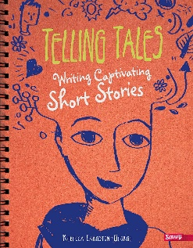 | School Library Journal - Carol Goldman, Queens Library, NY  "A conversational, friendly, encouraging tone enlivens the series. . . .Notable features include the visuals (strong, captioned photographs and colorful, quirky illustrations); “Your Turn” exercises, which provide stimulating writing prompts; and sidebars that highlight famed authors and excerpts from their works." - School Library Journal November 1, 2015

