Bring Writing to Life With an Author Visit

Rebecca Langston-George is the author of 15 nonfiction books for children including For the Right to Learn: Malala Yousafzai's Story, and The Booth Brothers: Drama, Fame and the Death of President Lincoln. She holds a Master of Education degree and recently retired from teaching. Serving as the Regional Advisor for the Society of Children's Book Writers and Illustrators (SCBWI CenCal), she helps other writers learn the craft, and serves on the board of the California Reading Association.

Playing with Poetry GRADES TK-1
A fast-paced, interactive 25 minute assembly on poetry with props & plenty of wiggle time. Students will leave with strategies to help them write about the world around them.

Biographies: Let’s Hear it for Heroes GRADES 2-6
A thought-provoking 40 minute assembly on Malala Yousafzai, Cesar Chavez & Charles Loring Brace (founder of the Orphan Trains) on how one person (YOU) can make a difference. Features standards-based writing tips.

All the Drama, Fame and Dirt Behind the History GRADES 6-12
A lively 40 minute assembly focused on the brothers Booth and their relationship with one another, President Lincoln, and the Civil War. Features writing tips and how to apply the lessons writers learn from rejection to persevere and achieve life goals.

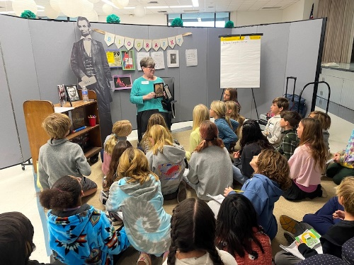 | 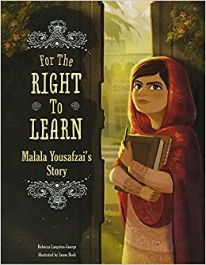 | 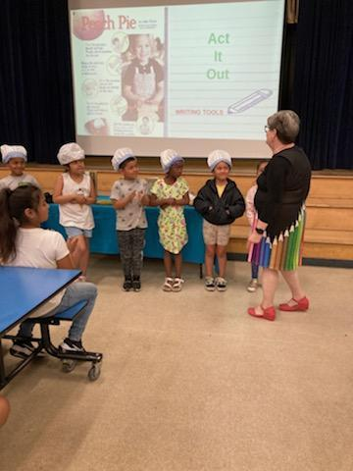

"Vibrant and engaging are the two best descriptors for presentations by Rebecca Langston-George. This educator and author combines her experiences to thoroughly delight audiences ranging from students to adults."
Sandra Yoon, Former Coordinator of Library Media Services, Bakersfield City School District,
Past-President California School Library Association

Prices for the 2023-2024 School Year

Overnight hotel & mileage reimbursement required for visits outside Kern or Ventura Counties.
*I’m also available to teach professional development sessions on classroom writing instruction.*

FULL DAY $1175  *Recommended*  3 Assemblies, –OR--  2 Assemblies + 1 writing workshop,  Q & A,  Quick class drop-in visits,  Book Signing, | HALF DAY $725  3 HOURS  1 Assembly (up to 200 attendees)  1 Writing Workshop (30 attendees)  Book Signing | EVENING FAMILY NIGHT $650  90 MINUTES  1 Assembly OR Writing Workshop  Q & A  Book Signing
Website www.rebeccalangston-george.com Email rebeccalangstongeorge@gmail.com

